**Week 8 LLO**

LO1 Define the standard deviation (Z) score of a data point as the number of standard deviations it is away from the mean

Z = (observation – mean)/SD

LO2 Use the Z score

* If the distribution is normal: to determine the percentile score of a data point (using technology or normal probability tables)
* Regardless of the shape of the distribution: to assess whether or not the particular observation is considered to be unusual (more than 2 standard deviations away from the mean)

LO3 Depending on the shape of the distribution determine whether the median would have a negative, positive, or 0 Z score keeping in mind that the mean always has a Z score of 0

LO4 Assess whether or not a distribution is nearly normal using the 68-95-99.7% rule or graphical methods such as a normal probability plot

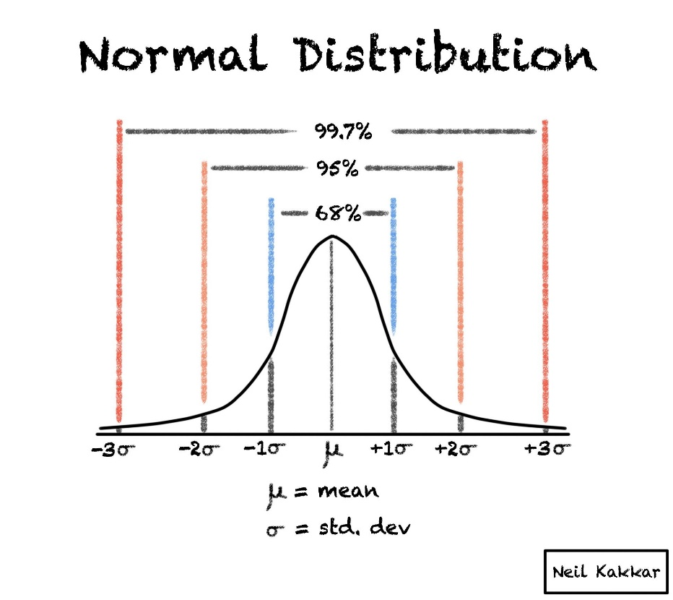

LO5 Determine if a random variable is binomial using the four conditions

1. The trials are independent
2. The number of trials, n, is fixed
3. Each trial outcome can be classified as a success or failure
4. The probability of a success, p, is the same for each trial

LO6 When the number of trials is sufficiently large, use the normal approximation to calculate binomial probabilities and explain why this approach works

* Conditions for this
  + np >= 10
  + n(1-p) >= 10

